

OpenCart

Shopping Cart User Guide – Version 1.1

**27 Feb 2014**

# Table of Contents

Table of Contents 2

Table of Figures 3

Introduction 4

Getting Started 4

Pre-Requisites and System Requirements 5

Installation 6

Install the Package 6

1. Download the package from Flo2Cash 6

2. Copy the file 6

Configuration 8

OpenCart Plugin Configuration 8

1. Navigate to the plugin configuration 8

2. Complete the configuration 10

Flo2Cash Web Payments Configuration 13

1. Navigate to Web Payments configuration 13

2. The return option 13

3. Basic styling options 14

4. CSS styling options 16

The Payment Flow 17

Checkout 17

Entering Card Details and Processing 17

Payment Results and Return Options 20

Appendix A – Uninstalling Version 1.0 22

1. Remove all plugin files 22

2. Confirm the removal 22

Glossary 23

# Table of Figures

Figure 1 – Navigating to the OpenCart Payments 8

Figure 2 – Confirming the installation 9

Figure 3 – Installing the plugin 9

Figure 4 - Flo2Cash plugin configuration 10

Figure 5 – Configure your Web Payments channel 13

Figure 6 – Changing the return option 13

Figure 7 – basic styling options 14

Figure 8 – Changing the basic styles 14

Figure 9 – Your logo and the payment page 15

Figure 10 – Configuring your own CSS 16

Figure 11 – Checkout and selecting Flo2Cash 17

Figure 12 - The Flo2Cash payment page 18

Figure 13 - Processing the payment 19

Figure 14 - Payment result - On Page 20

Figure 15 - Payment result - In OpenCart 21

# Introduction

## Getting Started

This document will guide you through the process of obtaining, installing and using the Flo2Cash secure payment gateway plugin for the OpenCart software. This guide is a technical document aimed at the web developer who is setting up and configuring the OpenCart software but will also provide the business or product owner with a useful description of the options available and the experience their customers will receive.

# Pre-Requisites and System Requirements

1. OpenCart is installed and working on your system
2. You have uninstalled previous versions of the Flo2Cash plugin – see appendix A

**Note**

The Flo2Cash plugin has been developed and tested against versions **1.5.4, 1.5.5** and **1.5.6** of the OpenCart software, although it may work fine with other versions.

# Installation

To use OpenCart for making web payments through your Flo2Cash account you will first need to install the plugin on you OpenCart system. For that you must manually copy the files to correct locations, this process is detailed below.

**Note**

If you had previously installed version 1.0 of the Flo2Cash plugin this will need to be removed first. Instructions for removing this are found in appendix A below.

**Important**

**Before installing the Flo2Cash plugin it is recommended that you make a full backup of your OpenCart installation.**

## Install the Package

To install the plugin directly to the file system, please follow the steps outlined below:

**Note**

The images used are from OpenCart v1.5.5

### Download the package from Flo2Cash

Download the package from the Flo2Cash website; this is available at the following URL:

[www.flo2cash.co.nz/cardacceptance/webpayments/shoppingcarts/opencart_v1.1.zip](http://www.flo2cash.co.nz/cardacceptance/webpayments/shoppingcarts/opencart_v1.1.zip)

The zip archive will contain two files:

1. Flo2Cash – Shopping Cart User Guide – OpenCart.pdf
2. Flo2Cash_Web_Payments_1.1.0.zip

The zip file is the package you will be installing in the next step.

### Copy the file

The installation files of Flo2Cash plugin will be in the zip file. Unzip all the files of the Flo2Cash plugin to your OpenCart folder.

If you are using **Linux** machine, the path to install Flo2Cash plugin should be \var\www\opencart.

If you are using **Centos** machine, the path to install Flo2Cash plugin should be \var\www\html\opencart

The file structure will be as specified in the below list:

\admin\controller\payment\flo2cash.php

\admin\language\english\payment\flo2cash.php

\admin\view\template\payment\flo2cash.tpl

\catalog\controller\checkout\flo2cash_failure.php

\catalog\controller\checkout\flo2cash_forged.php

\catalog\controller\checkout\flo2cash_success.php

\catalog\controller\payment\flo2cash.php

\catalog\language\english\checkout\flo2cash_failure.php

\catalog\language\english\checkout\flo2cash_forged.php

\catalog\language\english\checkout\flo2cash_success.php

\catalog\language\english\payment\flo2cash.php

\catalog\model\payment\flo2cash.php

\catalog\view\flo2cash\flo2cash_logo_sml.jpg

\catalog\view\theme\default\template\payment\flo2cash.tpl

The above files need to be copied into the OpenCart folder as per the path mentioned above.

# Configuration

Now the plugin is installed it needs to be configured to work with your Flo2Cash account. This will involve configuring the plugin and also optionally configuring some options for your Flo2Cash Web Payments channel that will allow you to customise both the payment flow and the payment screen layout, including adding your own branding.

**Note**

For the best user experience Flo2Cash recommends you change the default Web Payments return option, however, this will require your site to be hosted securely under SSL (the URL for your site begins with https://). Instructions on how to do this are described below in the “The return option” section of the Web Payments configuration below.

## OpenCart Plugin Configuration

To configure the plugin please follow the steps outlined below:

### Navigate to the plugin configuration

Login to the OpenCart admin panel and navigate to the “Extensions” item in the top menu bar and choose the “Payments” option as shown in the screenshot below.

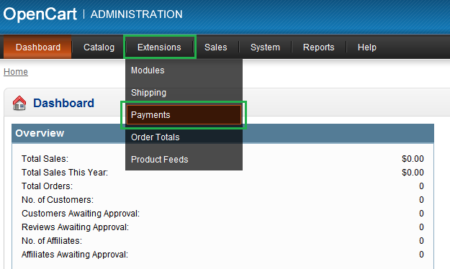

Figure – Navigating to the OpenCart Payments

If the plugin files were copied correctly at the right locations you will now see Flo2Cash as one of the payment methods available to be setup as a ‘Payment Method’.

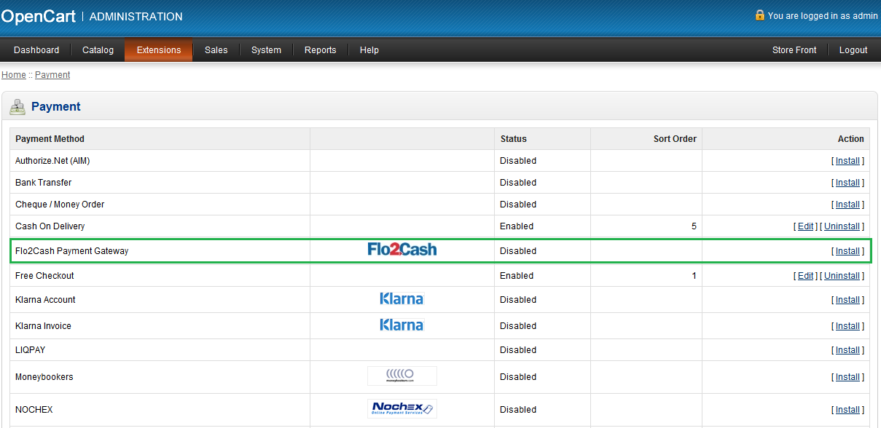

Figure – Confirming the installation

If you do not see the Flo2Cash module in the list you might need to refresh the server and browser.

Clicking on the “Install” link next to the Flo2Cash Payment Gateway module in the list will bring up two links “Edit” and “Uninstall”.

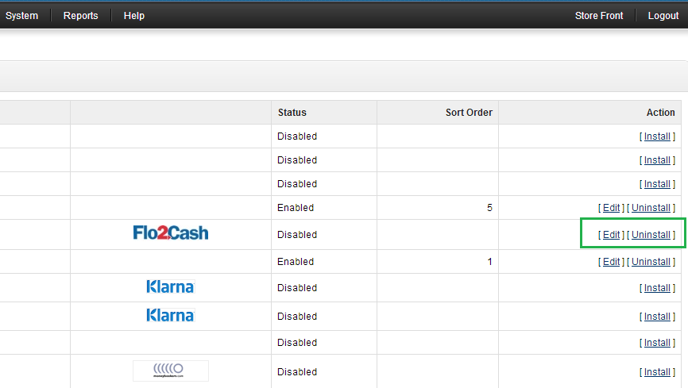

Figure – Installing the plugin

Clicking on the “Edit” button will bring up the settings form which will be displayed as the screenshot below.

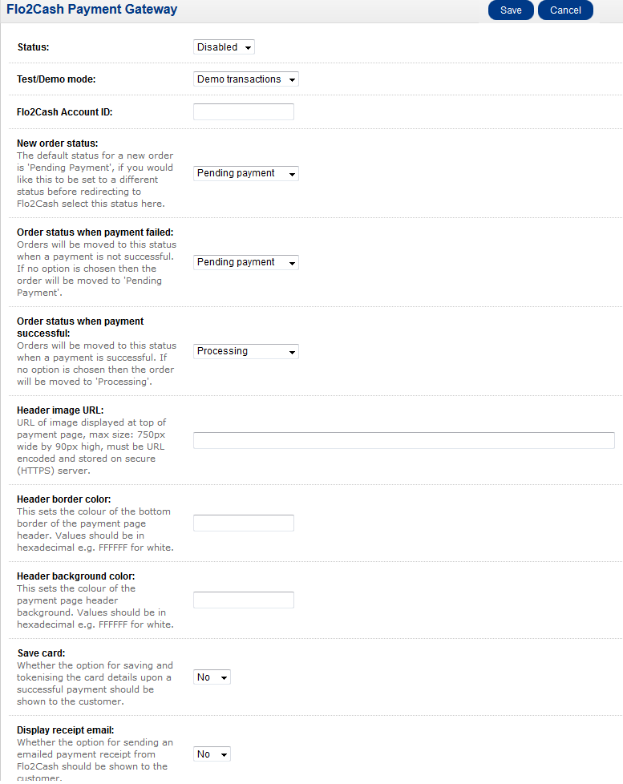

Figure - Flo2Cash plugin configuration

### Complete the configuration

There are a few options that must be completed and some that are optional. Each option is detailed below with a description and information on the data that can be used and where to find it.

#### Status (required)

This option allows you to decide whether the Flo2Cash payment gateway is an option for your customers at checkout, this should be set to “Enabled”.

#### Test/Demo mode (required)

This option allows you to switch between you demo and live Flo2Cash accounts. When performing your initial testing you will want to set this to “Demo transactions” and provide your demo account ID (below), however, this must be changed to “live transactions” when you put you system live.

#### Flo2Cash Account ID (required)

This is your Flo2Cash sub account ID used for making card payments. You will be issued with this when your account is created; it is a 5 digit number.

If you are using the plugin in demo mode (see above) you will need to put you demo account number here which will be a six digit number starting 62.

#### New order status (optional)

This is the status your order will be placed in when beginning the payment process. The default if you do not select an option is “Pending Payment”.

#### Order status when payment failed (optional)

This is the status your order will be moved to if the payment is declined. The default if you do not select an option is “Pending Payment”.

#### Order status when payment successful (optional)

This is the status your order will be moved to if the payment is successful. The default if you do not select an option is “Processing”.

#### Header image URL (optional)

Here you can provide a URL to an image that will be displayed on the top left of the payment screen. This is useful for putting your business logo on the payment page hosted by Flo2Cash.

**Note**

The URL to the image should be hosted securely under SSL (the URL will begin https://) to ensure your customer does not see any security warnings in their browser.

#### Header border colour (optional)

Here you can provide a hexadecimal value to set the colour of the bottom border of the header. The value should be six character hexadecimal values e.g. pass 000000 for a black border. If you do not provide a value the default will be white or any value that was previously set from your Flo2Cash Merchant Console.

#### Header background colour (optional)

Here you can provide a hexadecimal value to set the colour of the header background. The value should be six character hexadecimal values prefixed with a hash symbol (#) e.g. pass #FFFFFF for a white background. If you do not provide a value the default will be white or any value that was previously set from your Flo2Cash Merchant Console.

#### Save card (required)

This option allows you to display a checkbox on the payment page asking the customer if they would like to save their card. If they select this option Flo2Cash will tokenise their card details and you will be able to use them later for making additional payments. The tokens will be available through your Merchant Console. The default value for this option is “No”.

**Note**

Card details are saved only if the transaction is successful. Your Flo2Cash account must be subscribed to card tokenisation to make use of this option.

#### Display receipt email (required)

This option allows you to display a textbox on the payment page asking the customer if they would like to receive a payment receipt by email. If they enter their email address in the box provided Flo2Cash will send a PDF receipt to the email address provided. The default value for this option is “Yes”.

**Note**

You can customise the logo that appears on the transaction receipt in your Flo2Cash Merchant Console. Login to the console and navigate to the “Profile” menu item in the left hand menu.

## Flo2Cash Web Payments Configuration

Your Flo2Cash Web Payments channel contains a number of configuration options that allow you to customise the payment flow and look and feel of the payment page.

### Navigate to Web Payments configuration

To configure your Web Payments channel please login to your Merchant Console <https://secure.flo2cash.co.nz/client> using the credentials provided to you when you created your account. Navigate to the “Channel Settings” menu item in the left hand menu and select “Web Payments” from the resulting list.

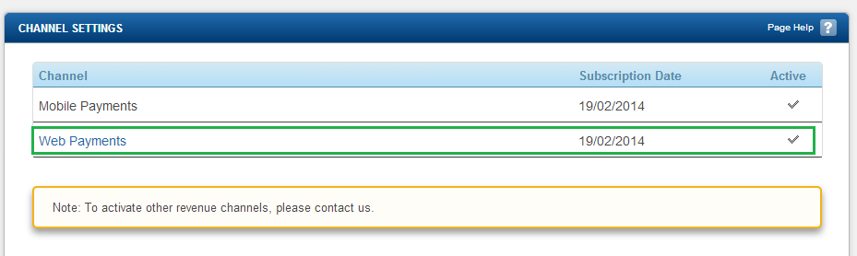

Figure – Configure your Web Payments channel

### The return option

The first configuration option available affects the payment flow your customer experiences. The default is for the customer to see the payment result on the Flo2Cash payment page and be presented with a button to return to your web site – see figure 14 below.

The alternative option to this is to have the payment page automatically return the customer to your website where OpenCart will display the result of the payment. To choose this option select the radio button for “Post to Return URL” and click the “Update” button at the bottom of the page.

**Important**

If you choose to automatically redirect your customer back to your website you should be hosting your website securely under SSL (your website URL begins https://) to avoid the customers browser showing them a security warning indicating they are moving from a secure to an insecure website.

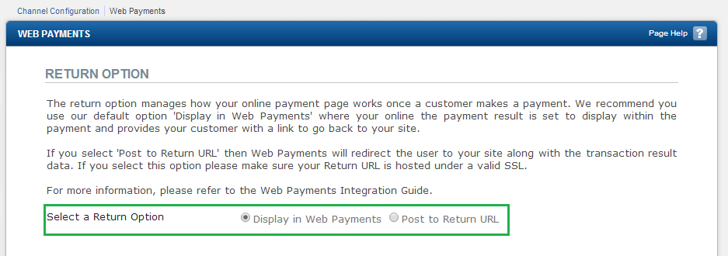

Figure – Changing the return option

### Basic styling options

The default styles for the payment page are to show the Flo2Cash logo in the top left of the page with a white background and white border – see figure 12 below. All three of these options can be changed to better reflect your brand.

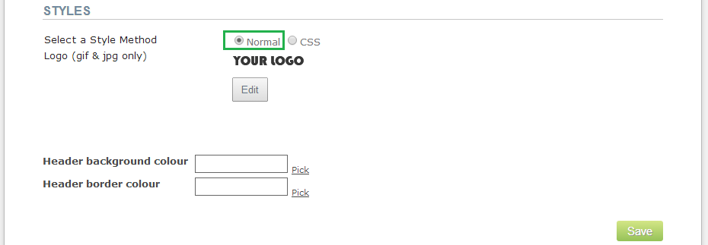

Figure – basic styling options

To change the default styles follow the instructions below.

#### Logo

To upload your logo click the “Edit” button which will display the upload controls. Click the “Choose File” button and select the image file from your local machine. Once you have selected the logo click the “Upload” button. You logo will be displayed to show you it has been uploaded successfully.

#### Header background colour

To change the header background click the “Pick” link next to the header background colour box and select the colour you would like the background to be.

#### Header border colour

To change the header bottom border colour click the “Pick” link next to the header border colour box and select the colour you would like the border to be.

Finally to apply your changes click the “Save” button.

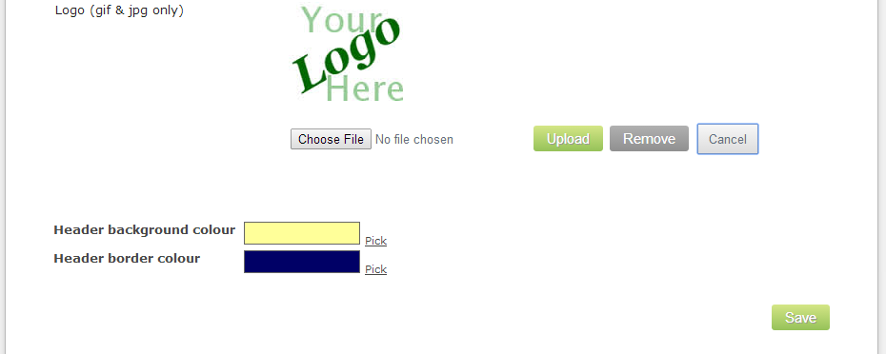

Figure – Changing the basic styles

Using the options selected in Figure 8 above the payment page would be rendered as seen in Figure 9 below.

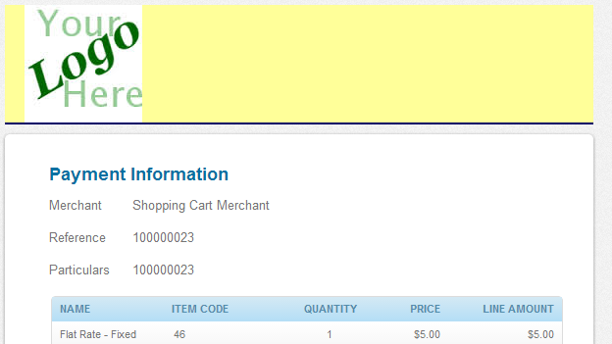

Figure – Your logo and the payment page

### CSS styling options

Alternative to the basic styling options is the ability for you to provide your own CSS file and images to customise fully the payment page look and feel. Complete instructions for this and to see the styles and options available please consult the main Web Payments integrations guide which can be downloaded at <http://www.flo2cash.co.nz/pdf/Flo2Cash%20Web%20Payments%20Integration%20Guide.pdf>.

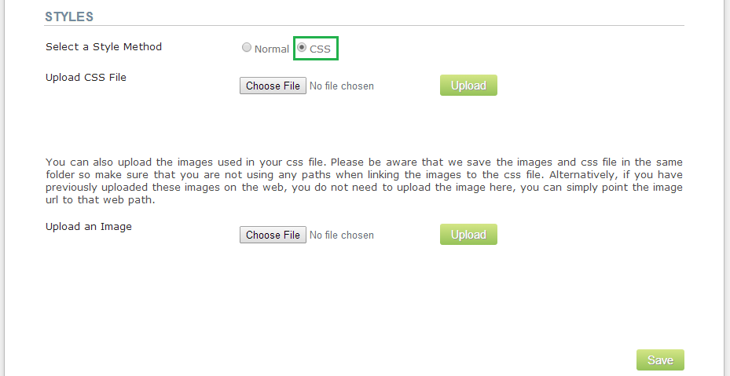

Figure – Configuring your own CSS

# The Payment Flow

This section will guide you through the payment experience your customers will have and explain how the different configuration options presented in the previous sections can influence this.

## Checkout

When the customer is at the checkout stage the fifth section “Payment Method” will list the payment gateways available to them. The Flo2Cash payment gateway will be listed (assuming it is enabled – see OpenCart Plugin Configuration above) and the customer selects this and clicks on the “Continue” button to proceed.

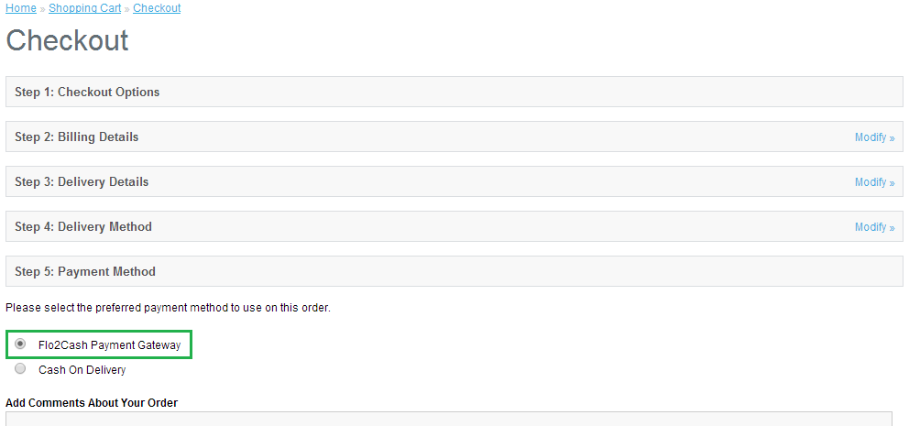

Figure – Checkout and selecting Flo2Cash

## Entering Card Details and Processing

After clicking Continue the customer will be redirected to the Flo2Cash payment page where they will see a list of the items they are paying for and a section where they can enter their credit card details. By default your account will be enabled to accept Visa and MasterCard cards, to accept other payment types such as American Express, Diners Club, China UnionPay, POLi and more please contact your Flo2Cash account manager.

If the “Display email receipt” option was selected the customer will be able to enter their email address to receive a PDF receipt for their payment.

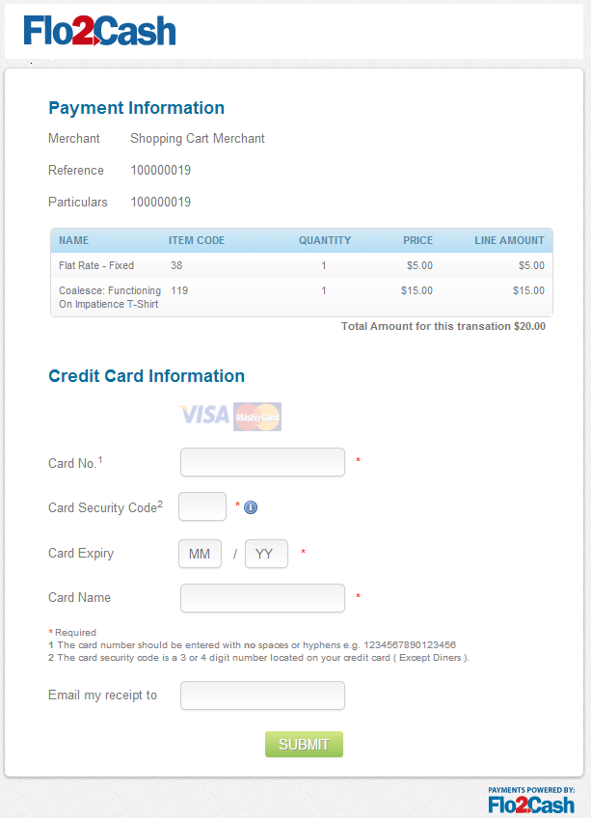

Figure - The Flo2Cash payment page

Once the customer has entered their card details correctly and clicked the “Submit’ button, they will see a processing page indicating the payment is being made.

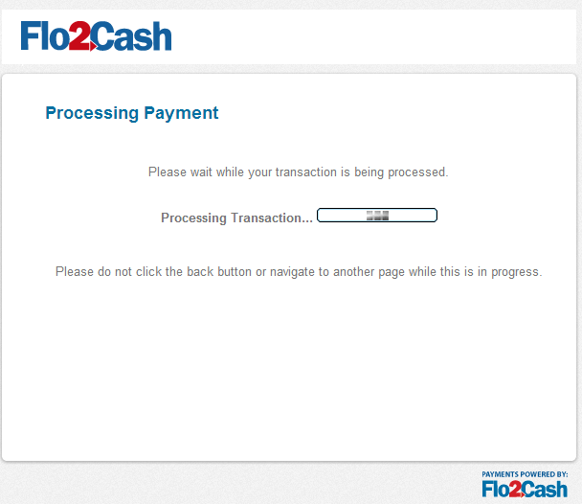

Figure - Processing the payment

## Payment Results and Return Options

If the merchant has set up their return option as display on payment page (see Flo2Cash Web Payments configuration section above) the payment result will be displayed to them as seen in Figure 14 below.

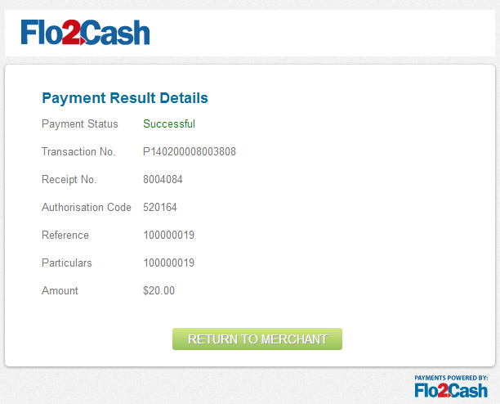

Figure - Payment result - On Page

If the merchant has set up their return option to return to the merchant site (see Flo2Cash Web Payments configuration section above) the customer will be redirected back to your website and the payment result will be displayed.

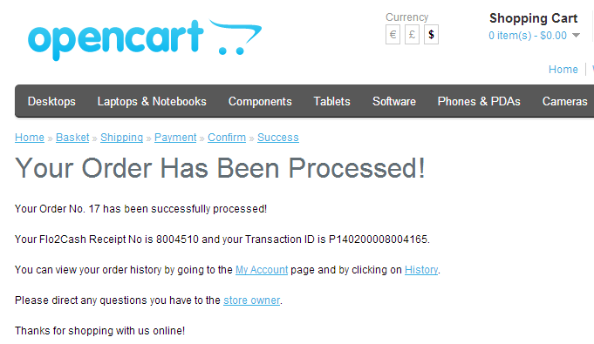

Figure - Payment result - In OpenCart

**Note**

Flo2Cash sends an asynchronous message to OpenCart to update the status of the order regardless of the return option chosen. Due to the nature of this asynchronous request the order status may take a few seconds to update.

# Appendix A – Uninstalling Version 1.0

If you have previously installed version 1.0 of the Flo2Cash plugin you will need to remove this before installing newer versions. The steps below will guide you through uninstalling version 1.0.

## Remove all plugin files

The first step is to remove all plugin files from the OpenCart folder structure. These files can be found at the following locations:

\admin\controller\payment\flo2cash.php

\admin\language\english\payment\flo2cash.php

\admin\view\template\payment\flo2cash.tpl

\catalog\controller\checkout\flo2cash_failure.php

\catalog\controller\checkout\flo2cash_forged.php

\catalog\controller\checkout\flo2cash_success.php

\catalog\controller\payment\flo2cash.php

\catalog\language\english\checkout\flo2cash_failure.php

\catalog\language\english\checkout\flo2cash_forged.php

\catalog\language\english\checkout\flo2cash_success.php

\catalog\language\english\payment\flo2cash.php

\catalog\model\payment\flo2cash.php

\catalog\view\flo2cash\flo2cash_logo_sml.jpg

\catalog\view\theme\default\template\payment\flo2cash.tpl

## Confirm the removal

Finally login to the OpenCart admin panel and navigate to Extensions -> Payments and check that the Flo2Cash payment gateway is no longer displayed.

# Glossary

|  |  |
| --- | --- |
| Term | Interpretation |
| F2C | Flo2Cash |
| MNS | Merchant Notification Service |